Data Processing:
Download any dataset with numeric values to plot the histogram as per the values given by the user:
  - Read the x-axis values from the user which are the values where edges of the histogram’s bars are lying.
  - Read Number of bins to display
  - Read the bar color and edge color to display
  - Read the transparency value of bar color to display
  - Read colors of each bar to display
[Do some data wrangling to get the data in good shape to plot, if required.]
- Using your random number generator program, generate age for 100 persons and display the age like barcode.
- Prepare the contour graph for numeric data as shown in the following:
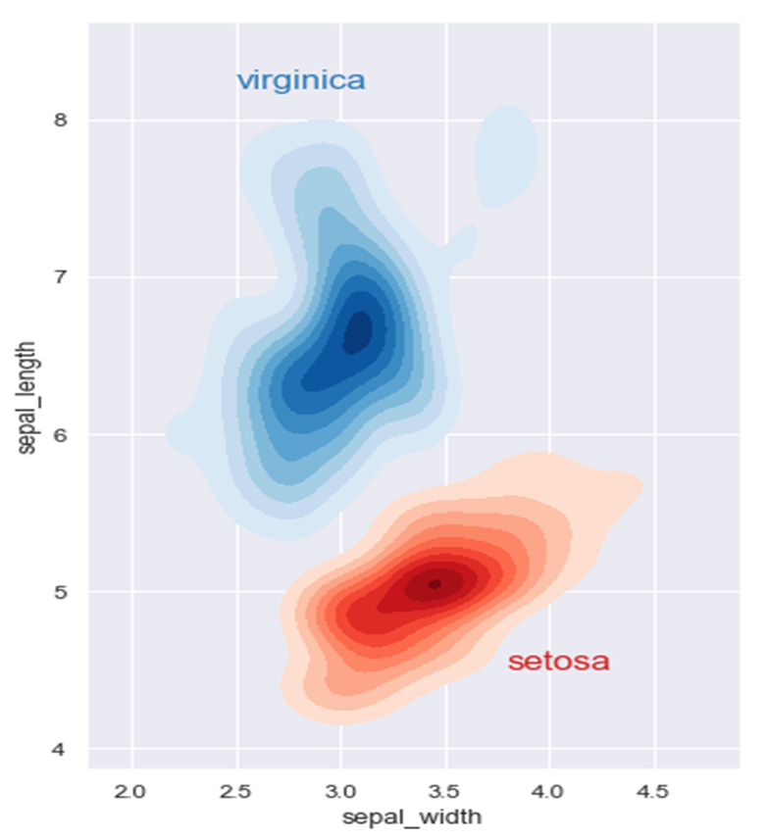
- Prepare the heatmap as shown in the following:
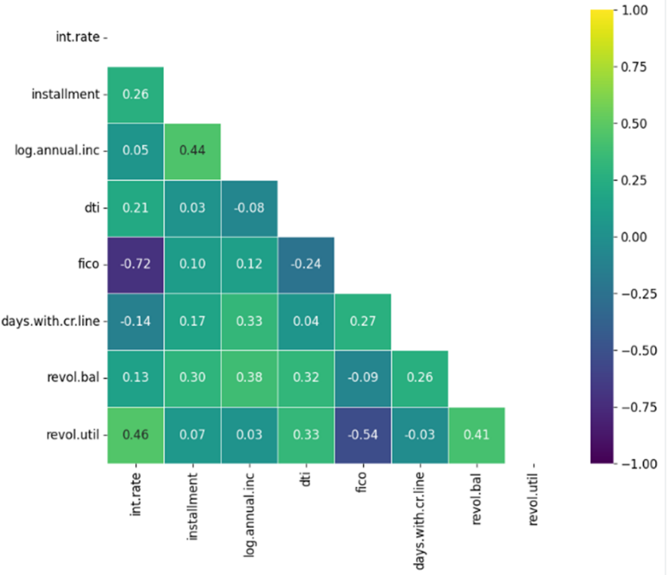
- Download the Earthquake data of India from Kaggle and for a time you are interested in (the data starts from 2018). Do some data wrangling to get the data in good shape to plot, if required.
  - Use the Colour-code of the points based on the depth of the earthquake.
  - Use the size of the point/bubble to represent the magnitude of the earthquake.
  - Label the visualization for easy understanding.
  - Report the result analysis of your visualization.
- Use the diabetes data set from UCI and Pima Indians Diabetes data set for performing the following:
- Using built in functions explore both the datasets.
- Perform Bivariate analysis: Linear and logistic regression modeling
- Perform Multiple Regression analysis
- Compare the results of the above analysis for both the datasets.

- Data Repositories
UCI Repository
Kaggle Dataset
Earthquake Data India
NASDAQ Dataset
Google Public Dataset

